**College Event Feedback Analysis**

**Mini Report**

**Project Overview**

This project analyzes student feedback from various college events (e.g., workshops, seminars) using text and rating-based responses. The aim is to identify key satisfaction drivers and improvement areas using data science techniques like sentiment analysis and data visualization.

**Tools & Technologies**

* Python libraries: pandas, seaborn, matplotlib, TextBlob, wordcloud
* Platform: Google Colab / Jupyter Notebook

**Dataset Description**

The dataset contains student feedback collected after college events. It includes:

* Numerical ratings (1–10 scale) for various aspects such as communication, organization, and overall experience.
* Open-text comments provided by students reflecting their experiences.
* Generated sentiment scores for each comment using TextBlob (ranging from -1 to +1).
* Sentiment labels (Positive, Neutral, Negative) based on polarity thresholds.

This dataset helps analyze both quantitative (ratings) and qualitative (comments) feedback to identify satisfaction trends and improvement areas.

**Dataset Link** -> <https://www.kaggle.com/datasets/ruchi798/student-feedback-survey-responses>

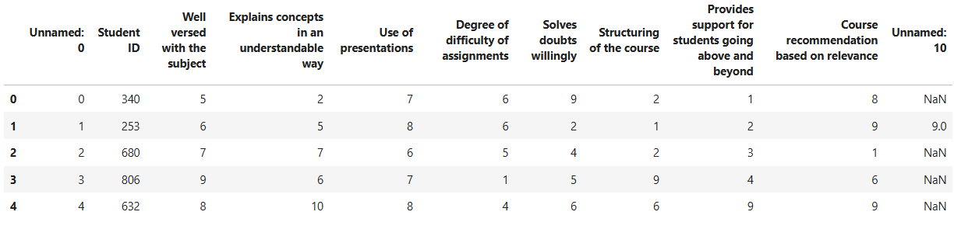

**Analysis Methodology**

To extract actionable insights from the dataset, we followed these steps:

1. **Data Cleaning** - Removed unnecessary columns and renamed others for clarity.
2. **Sentiment Analysis** - Used TextBlob to calculate sentiment polarity scores for each comment:
   * Positive (score > 0.1)
   * Neutral (score between -0.1 and 0.1)
   * Negative (score < -0.1)

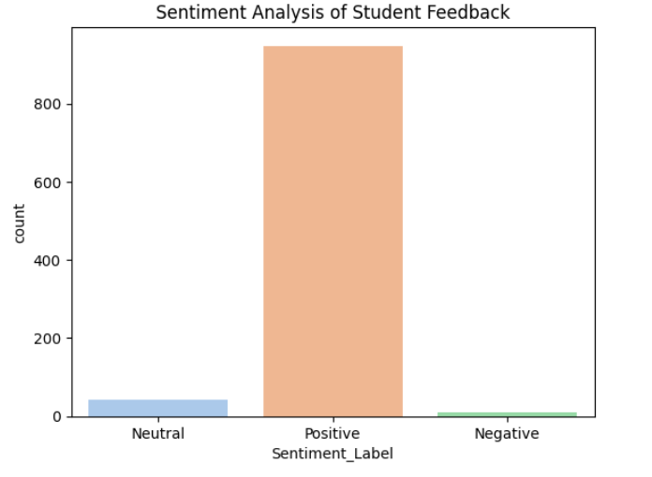

1. **Rating Analysis** - Analyzed numerical scores using statistical summaries and visualizations (boxplots, bar charts).

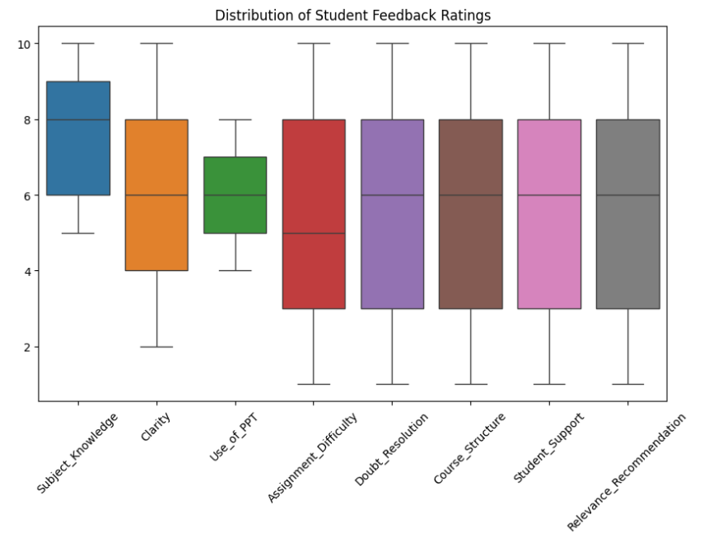

1. **Word Cloud Visualization -** Generated a word cloud to highlight frequently mentioned terms in feedback.

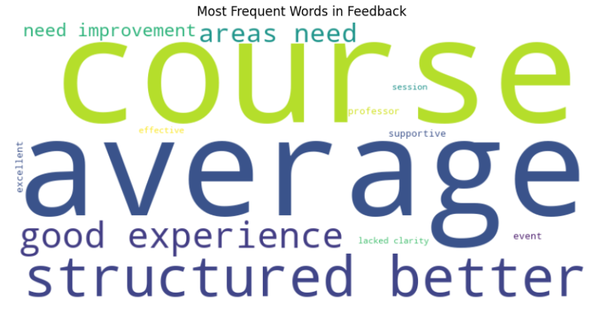

1. **Insight** **Extraction** - Interpreted patterns from sentiment and rating data to form conclusions and suggestions.

**Key Insights**

The analysis of both rating and textual feedback has provided several important findings:

1. Most feedback was positive, especially in areas like Subject Knowledge and Doubt Resolution.
2. Assignment Difficulty and Time Management received relatively lower ratings and some negative sentiment.
3. Students appreciated supportive faculty and clarity but showed concern over practical delivery and pace.

**Recommendations**

Based on the findings, the following actionable steps are suggested to improve future events and courses:

1. Improve Time Management - Ensure that sessions follow a tighter schedule and respect time slots.
2. Add Practical Demonstrations - Include hands-on examples or real-life applications to support theoretical content.
3. Simplify Complex Assignments - Ensure assignment difficulty is aligned with the course level and clearly explained.
4. Enhance Interactive Session - Allow more time for Q&A, student participation, and feedback during sessions.

**Conclusion**

This analysis offered key insights into student satisfaction across college events. By combining sentiment analysis with visualizations, we identified strengths like faculty support and subject knowledge, along with areas needing improvement such as practical relevance and assignment clarity. These findings can help guide future event planning with a student-focused approach.